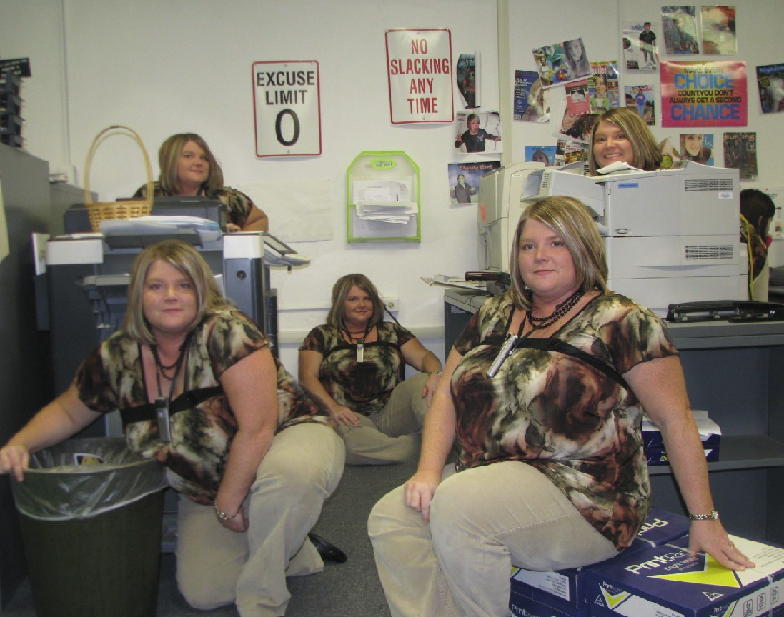
PHOTOSHOP CLONE PROJECT
GUIDELINES
Using a camera on a tripod, capture at least five images of yourself posing (not just standing straight up!). If the camera has a remote control or an automatic shot or burst feature, utilize this (see the manual). It is important that the camera remain as still as possible. It would not hurt to take a few extra shots, just in case.
- Take a minimum of FIVE photos of yourself (or have someone else) using a tripod. I’d take a few extras.
- Copy the photos to your computer. Use the Photoshop Automate feature to Photomerge these files (with no blending). SEE THE TUTORIAL—CLONE PROJECT HELP SHEET (there’s also a video).
- One at a time, turn on layers starting at bottom and moving up. Add a mask to each layer above as you go, filled with black, and then paint yourself back in on the mask using white.
- If you notice any problems with the photos (especially colors if you didn’t use a flash or depending on the length of the subject from the lens, you might need to modify the Hue/Saturation on a specific layer to better match (Control+U).
- Crop the image if needed (if you see any transparent spots around the edges).
- Add your name in a “cool” text (use bevel, drop shadow, etc.) someplace on the project.
- Print a contact sheet page (File, Automate, Contact Sheet II—be sure your originals are all in a folder) that has your original photographs (can be black and white); then, print the final one as a full sheet in color.
SCORING
Um….not so much Whoa, buddy! Awesome!
5+ Photos Used 1 2 3 4 5
Quality of Cloning 2 4 6 8 10
Creative Use of Fonts/Effects 1 2 3 4 5
Creativity of Poses 1 2 3 4 5
Overall Image (realism) 1 2 3 4 5
Source Photos Printed (one pg) 1 2 3 4 5
Final Printout (full page/color) 1 2 3 4 5

TOTAL: _____/40 pts

Name:______________________________________

